Carnelian

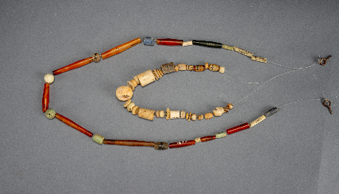
Beads; Carnelian; Findspot: Mohenjo-daro, Pakistan; 2600¬1900 BCE; CSMVS

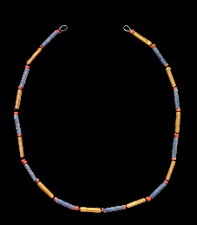
Necklace of Queen Puabi; Gold, carnelian and lapiz lazuli; Early Dynastic III, Findspot: Ur, Iraq; 3rd millenium BCE; The British Museum (1929,1017.237)

